Client didn't send the content
“Hey [Client],
Hope you’re doing great.
I know providing content for a website can be a daunting task. This usually happens if there’s not enough clarity as to how it’s supposed to be done.
If that is the case, I apologise for lack of clarity and I implemented a system to help us pass this hurdle so we can get the project back on track.
I’ve installed a great feature called WP FeedBack on your website that will allow you to submit content in a much easier and efficient way so we can get your project up and running again.
It makes the process super simple, just click the + icon on the website to leave the new content visually and within context.
If you want to learn a little more about it, here’s a short video: https://www.youtube.com/watch?v=PtTHZgRdK5A&ab_channel=WPFeedBack
I’ve already got you all setup to get going, after watching the video simply hit this link: {Insert URL to client’s site or development environment}
And start entering in the content! This new feature can even be used on your tablet or your phone!
Let me know if you have any questions”

Client didn't approve the design

“Hey [Client],
Hope you’re doing great.
Sometimes, approving a design for a website can be a daunting task. This usually happens if there’s not enough clarity as to how it’s supposed to be done.
If that is the case, I apologise for lack of clarity and I implemented a system to help us pass this hurdle so we can get the project back on track.
I’ve installed a new feature on your website that will make it super easy to tell me what you like, and what you don’t like.
It makes the process super simple, just click the + icon on the website to point out any part of the design.
If you want to learn a little more about it, here’s a short video: https://www.youtube.com/watch?v=PtTHZgRdK5A&ab_channel=WPFeedBack
I’ve already got you all setup to get going, after watching the video simply hit this link: {Insert URL to client’s site or development environment}
And start adding notes on the page! This new collaboration system can even be used on your tablet or your phone!
Let me know if you have any questions”

Support requests are getting out of hand

“Hey [Client], Hope you’re doing great. I think we are both feeling a little overwhelmed at the moment due to our communications being in multiple different places and it’s slowing down the progress of tasks on your website.
To combat this and get things sorted for you quicker and easier, I have installed a new feature on your website that will make it super easy to tell me what you like, and what you don’t like or flag anything that needs my attention.
Here is a quick video that explains how to use it: https://www.youtube.com/watch?v=PtTHZgRdK5A&ab_channel=WPFeedBack
I’ve already got you all setup to get going, after watching the video simply hit this link: {Insert URL to client’s site or development environment}
And start adding notes on the page!
This new collaboration system can even be used on your tablet or your phone!
Since this is now going to be the way we will communicate with each other: From your phone, please click on this link and save it to your phone’s home screen.
Android: Tap the menu button and tap Add to homescreen.
Apple: Tap the Share button on the browser’s toolbar and tap the Add to Home Screen icon.
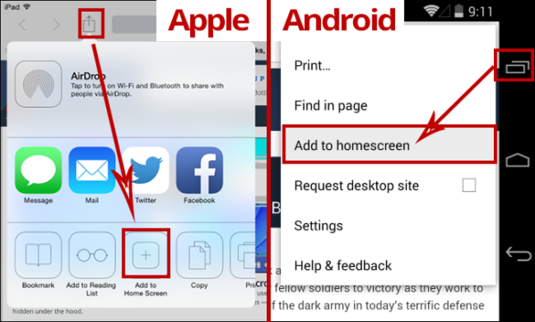
This will give you direct access to your website as well as to reach out to me if you need anything. Simply click the + icon on the right side of the screen to choose any part of the page to attach a message.
You can also open the feedback sidebar (below the + icon) and click the “General” button to make generic requests that are not about a specific part of the page.
Click here from your phone: [Insert URL to client’s site that includes the login parameter]
Let me know if you have any questions”

